## 1. Install OpenJDK

$ sudo apt update

$ sudo apt install openjdk-8-jdk

$ java -version

## 2. Download Gradle

$ wget https://services.gradle.org/distributions/gradle-5.2.1-bin.zip -P /tmp

sudo unzip -d /opt/gradle /tmp/gradle-*.zip

## 3. Setup environment variables

$ sudo vi /etc/profile.d/gradle.sh

export GRADLE_HOME=/opt/gradle/gradle-5.2.1

export PATH=${GRADLE_HOME}/bin:${PATH}

$ source /etc/profile.d/gradle.sh

## 4. Verify the Gradle installation

$ gradle -v

**Conclusion**

You have successfully installed **Gradle** on your **Ubuntu 18.04 LTS** / **Ubuntu 16.04 LTS**. You might want to check the following guides:

Build and run Java using Gradle CLI

C:\Users\chinnajee.rao>cd \

C:\>

C:\>md gradleproject/task1

C:\>cd gradleproject/task1

C:\gradleproject\task1> md src/main/java/demo

C:\gradleproject\task1> cd src/main/java/demo

C:\gradleproject\task1\src\main\java\demo>

C:\gradleproject\task1\src\main\java\demo>notepad HelloGradle.java

package main;

class HelloGradle{

public static void mail(String...args){

System.out.println("Hello Gradle!");

}

}

C:\gradleproject\task1\src\main\java\demo>

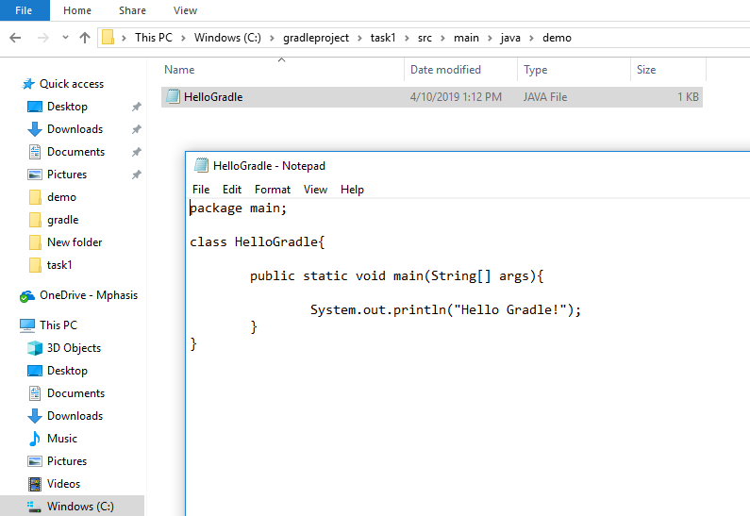

C:\gradleproject\task1> notepad build.gradle

apply plugin : 'java'

apply plugin : 'application'

mainClassName = 'demo.HelloGradle'

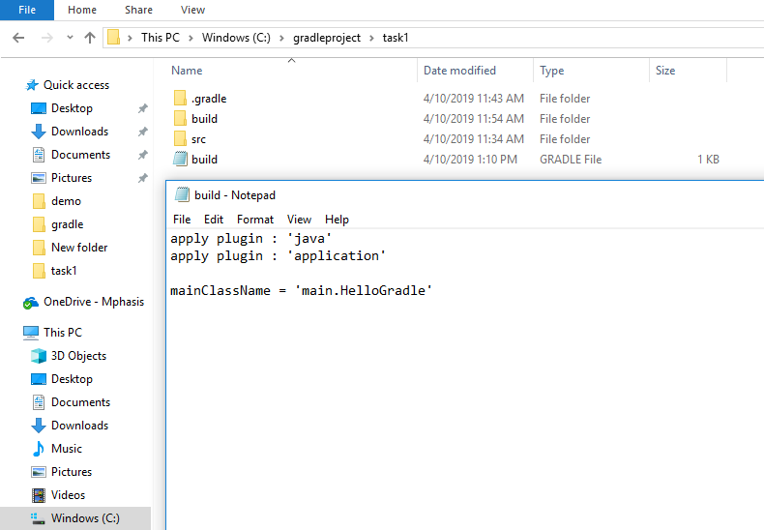

C:\gradleproject\task1>gradle build

BUILD SUCCESSFUL in 4s

5 actionable tasks: 5 executed

C:\gradleproject\task1>

C:\gradleproject\task1>gradle run

> Task :run

Hello Gradle!

BUILD SUCCESSFUL in 5s

2 actionable tasks: 1 executed, 1 up-to-date

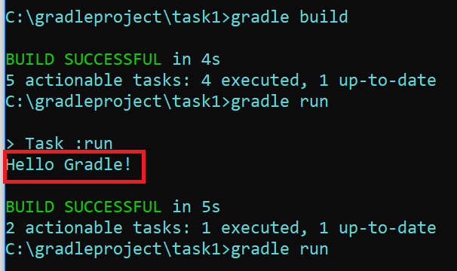

**Conclusion**

You have successfully Build and run Java **Gradle** on your **Ubuntu 18.04 LTS** / **Ubuntu 16.04 LTS**.